**Assignment 2 – Design Document**

Group 11: Annie Berend, Tobias Heckel,

Christos Stylianos Vazouras, Žan Zafošnik

20.11.2020

**Description of activities**

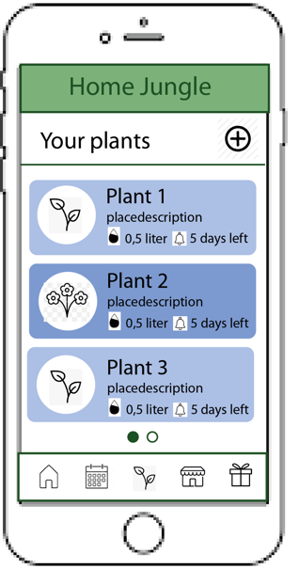**Home / Plants**

The home screen displays a list of the user’s plants. For each plant we display an image, its species name, a short description (like its location at the user’s home), when it needs to be watered next and how much water it needs. Every plant information is displayed on a blue-colored area. The blue gets darker if the plant needs water soon, so that the user gets an instant visual feedback, when he or she enters the home screen. You will be able to scroll down to see more plants if you have a lot of plants. If the user wants to remove a plant he can swipe left or right on it and a pop up will appear asking if the user is sure about the removal of the plant.

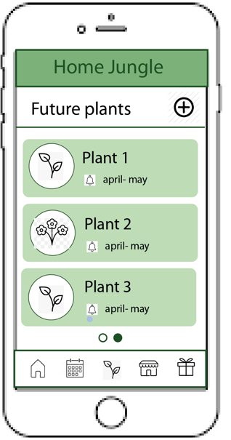**Future plants**

In the future plants screen the user can plan which plants he wants to grow next / in the next season. The screen is similar to the home/plants screen. For each plant we display an image, its species name, a short description and when the user planned to start growing the plant. If the user wants to remove a future plant he can swipe left or right on it and a pop up will appear asking if the user is sure about the removal of the plant.

Example: The user wants to grow tomatoes on his balcony and he wants to be remembered when he needs to plant the seeds.

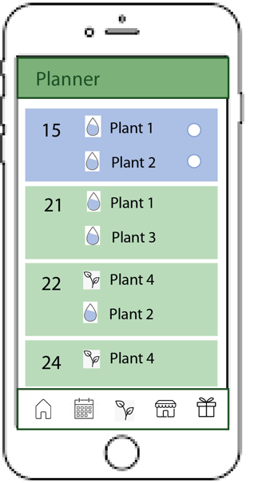**Calendar/Planner**

In the calendar the user sees the upcoming notifications/events. The list is ordered by date starting with today. For each day, we list the plants that need to be watered (from home/plant screen) and the seeds that the user wants to plant (from future plant screen). Once the user has performed the action, he can dismiss the actions by checking a checkbox.

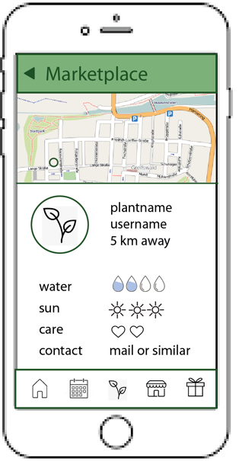

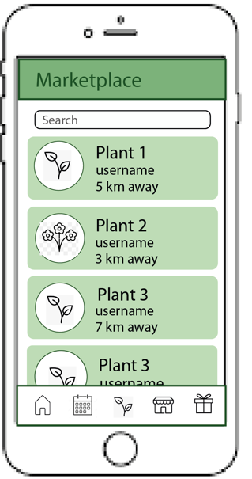**Marketplace**

The marketplace lists plants/seeds/seedling give-aways of other users in the local area of the user. Each list item consists of a picture of the give-away, the species name and the user name. The list is sorted by the distance to the user and is limited to a maximum distance of 10km.

When a give-away is selected on the marketplace, its details are displayed on a separate activity.

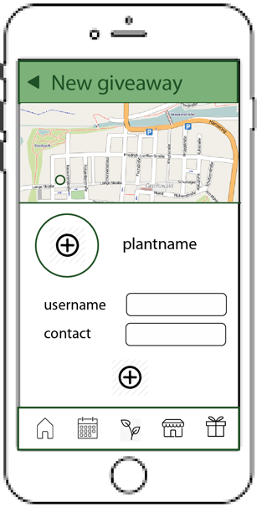

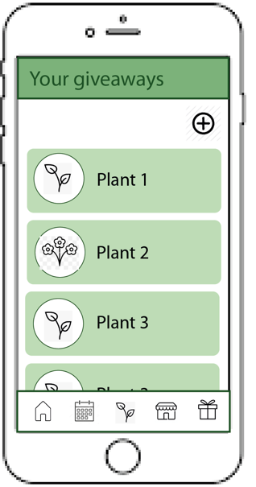**Give-aways**

The give-aways screen shows a list of plants that the user offers on the marketplace. He can add new give-aways and remove offers by swiping an item to the left or right.

**Database**

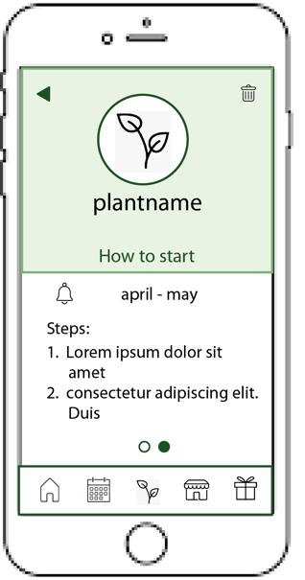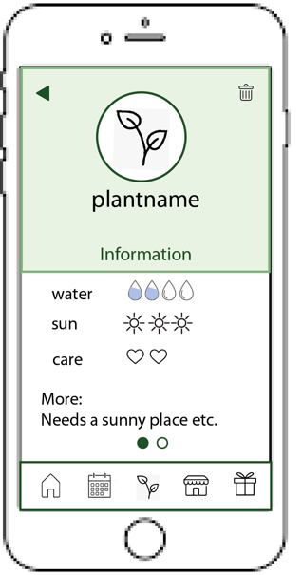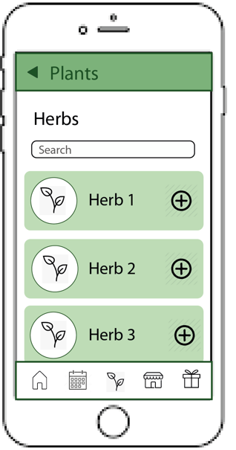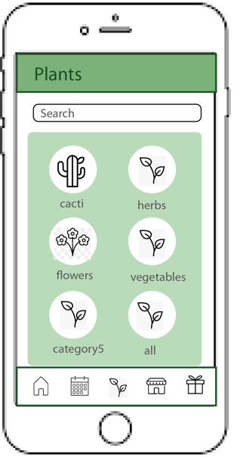

The database lists all known plant species. First, we display a list of categories. If the user selects one of them, the plant species in the selected category are displayed. Additionally, the user can always search for plant species in both screens (categories and species list). When the user selects one species, all the information about the plant species are shown in a new activity. Finally, the user can add this plant species to his plants or future plants or he can create a give-away for this species.

**Description of workflows**

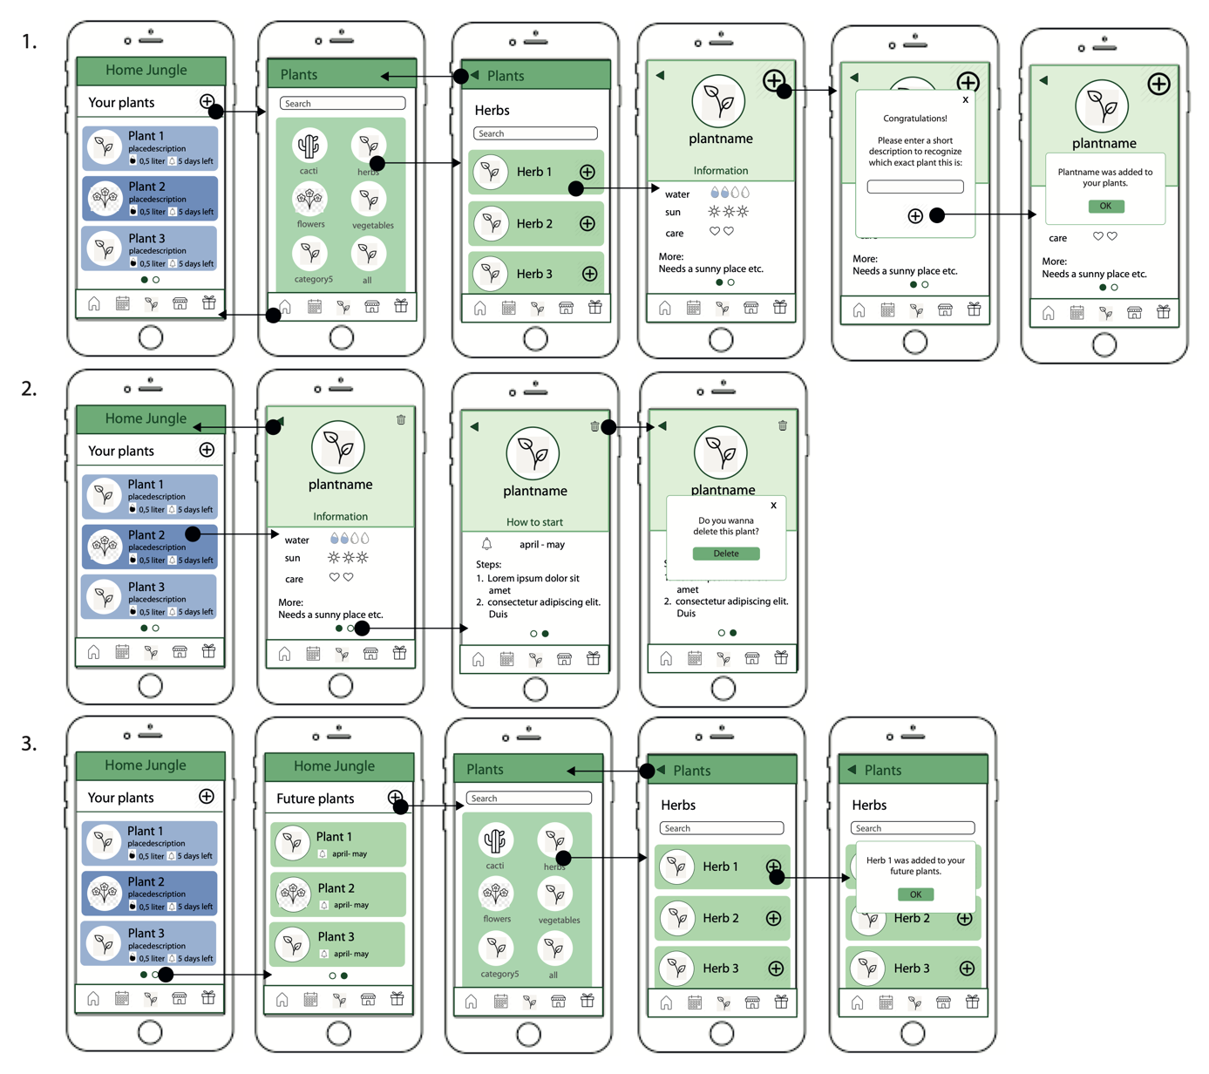

**Use case 1: Adding a new plant to your plants**

The user is located on the home/plant screen and wants to add a new plant to his plants (in order to get remembered to water it). The user clicks on “+”, selects the plant species from the database and once he has found the correct plant he clicks on “+” on the plant details page. As the user might have the same plant several times, he can add a description to the plant that is displayed in the home/plant screen.

**Use case 2: Seeing details about plant or deleting plant**

The user is located on the home/plant screen and wants to see further details about his plant (e.g. in order to know where he should place the plant) or wants to delete it (e.g. as the plant is dead). He clicks on the plant and its general information are shown (like how much water or sun it needs). When the user swipes to the left, he can also see information about how the seeds are planted. When the user wants to delete the plant, he can click on the “delete” symbol on the details page.

**Use case 3: Seeing and adding future plants**

The user is located on the home/plant screen and wants to see the plants he intends to plant in the future and he wants to add a new one (in order to get remembered when he should plant the seeds). The user can swipe the screen to the left to see the second page of the home/plant screen where the future plants are listed. There he can see when he needs to plant the seeds or can access more information about the plant by clicking on it. When he wants to add a new future plant, he clicks on “+”, selects the plant species from the database and once he has found the correct plant he clicks on “+” on the plant details page. Then the plant is added to his future plants.

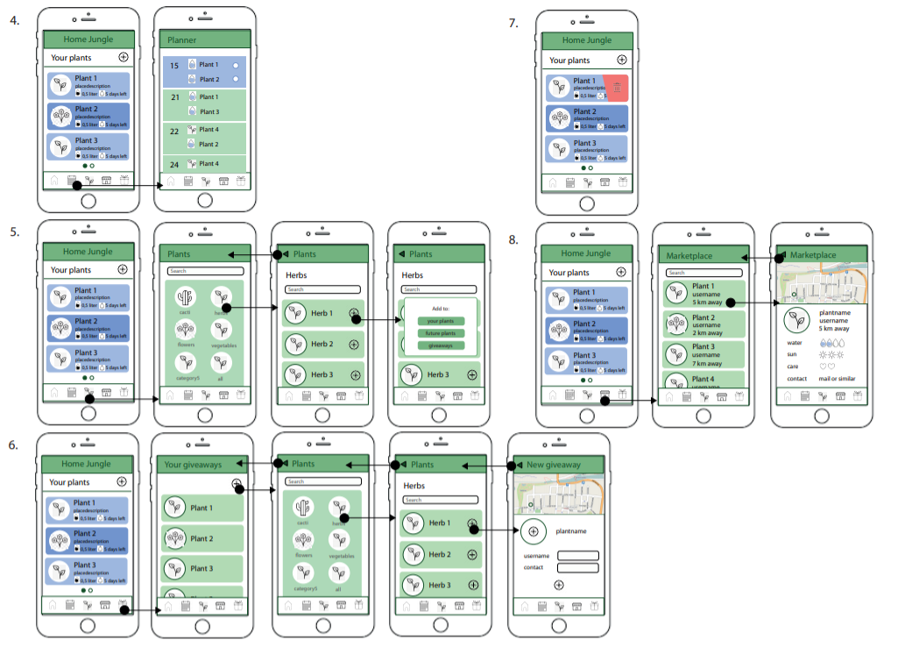

**Use case 4: Viewing the Planner**

The user is located on the home/plant screen and he/she wants to check out the watering and planting dates for his plants (e.g. when to water specific plants and when to plants your). The user can click on the calendar icon at the bottom. By doing so the user then views the planner.

**Use case 5: Viewing the Database**

The user is located on the home/plant screen and he/she wants to check out all of the plants that are in the database (e.g. the user wants to look for s specific plant or just look up interesting plants for his future plans). The user can click on the plant icon at the bottom. Which will take him to the Plants database. There he/she can view the plants by categories/species. By clicking on one of them he will be redirected to the subpage of the database with the applied filter. By pressing the “+” the user can add the selected plant to “Your plants”, “Future plants” or “Giveaways”.

**Use case 6: Giving away seed and seedlings**

The user is located on the home/plant screen and wants to giveaway some seeds or seedlings. The user can do so by clicking on the gift icon on the bottom and he/she will be shown the “Your Giveaways” site. There the user can view and remove his/hers already existing giveaways. By clicking on the “+” the user can add another plant to their giveaways. The user will be than shown the database where he/she can firstly select the plant type/spices and secondly select the plant the user wants to giveaway by pressing the “+” next to the plant the want to give away. Once the user does that they will be sent to the map where they will be asked to input their username and contact information as well as upload some photos of the giveaways.

**Use case 7: Deleting a plant from your plants**

The user is located on the home/plant screen and wants he/she wants to delete one of the entries in the home screen. The user can do so by swiping left on the plant. That will make a prompt to pop out and ask the user if he/she is sure about that.

**Use case 8: Using the Marketplace**

The user is located on the home/plant screen and he wants to check out the marketplace. The user can click on the marketplace icon on the bottom. By doing so the user is that shown the marketplace site where he/she can see all off the offers near them. By clicking on one of the offers the user is than shown a map where the person who is trading away or offering the seeds or seedling is approximately located. The user will be also shown all of the needed date, which is how much water does that plant need, how much sun does that plant need, how much care does it need and most importantly the contact details about the other user/trader.

**Has the UI design been evaluated in some form, and what were the outcomes of that evaluation?**

To evaluate the design of the user interface, we took a closer look at some of the 10 usability heuristics for user interface design. We ensured that the design fulfils the criteria so that the app will give an enjoyable and satisfactory user experience:

*Match between system and the real world*

The application is designed so that it is easier for the user to understand. Using familiar concepts, words and images, the user can associate application elements with those of the real world. Examples of this include the basic activities:

* Home, by using a simple house picture to symbolize it.
* Calendar, which uses a traditional calendar picture.
* Marketplace, of which both the name and the picture are taken from the real world.
* Give-aways, by using a wrapped present with a ribbon bow.

*Consistency and standards*

We use consistent UI elements across the complete app. Examples of this include:

The “plant database” activity that consists of first the plant category and then the list of species is used in three different locations in the app: adding a new plant, adding a new future plant and in the plant database tab of the app itself.

In the home/plant screen the user can switch between two pages by swiping left or right: plant and future plants. We used the same mechanism in the plant details page for the two pages “general information” and “how to plant”. These correspond to the home/plant screen: The first page corresponds to the current plants of the user and how to water/care for them. The second page corresponds to future plants and explains how to plant the seeds.

The placement of buttons is consistent across the app. Adding a new item is always a “+” button on the top right. Deleting an item is always done by swiping the element left.

*Error prevention*

The user is always asked before he/she wants to add or delete a plant or giveaway, so that an unintended click on a button won’t cause an irrevocable deletion or an addition of a dataset, that then must be deleted again. This is done by showing a pop-up window/another screen, when a user wants to delete or add something, so that he/she has to confirm it.

*Aesthetic and minimalist design*

Application is based on only a few colours which gives it the minimalist feel as well as the information presented on the screen is shown by mostly icons and not long texts. The design is clean and aesthetic trying not to crowd up the screen of a user. The white screen in the background gives other buttons, icons and fields a feeling of importance.

*User control and freedom*

The user can pick any of the plants that are available in the database and is not limited to only a few. The user can also choose to post his/her seeds and seedlings on the giveaways and is in no condition forced into it. The user is also allowed to switch between all the given screens at any time as well as browse the marketplace without complications. The only restriction is that the user has to connect to the internet to use marketplace and giveaways.

**Is the design of the interfaces consistent so that the user can easily find the UI elements in an easy and efficient way?**

* consistent icons, font, button style, colours
* consistent list items for plants (in plants/future plants/marketplace)
* for more see “Consistency and standards” in the question before

**Which data is stored on servers, and which is stored locally?**

* Locally
  + plants, future plants
  + calendar
* Server
  + marketplace / give-aways
* Not decided yet
  + plant species database